user guide

1. Config SQL server 2005 system :

step 1: Open SQL server configuaration manager

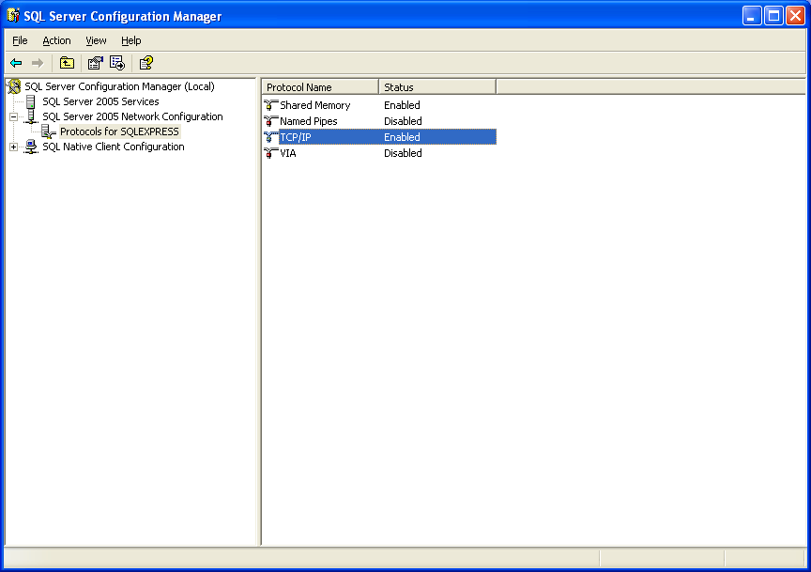

step 2 :

set Enable = Yes
TCP Dynamic Ports : 1433

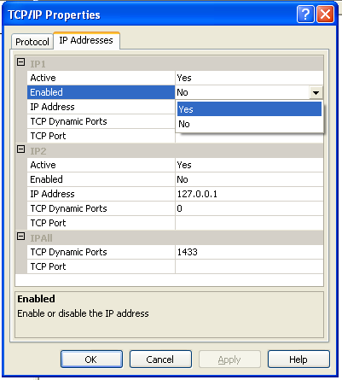

step 3 :

Config Server Properties
Select : Security ---> Choice SQL server and window Authentication mode

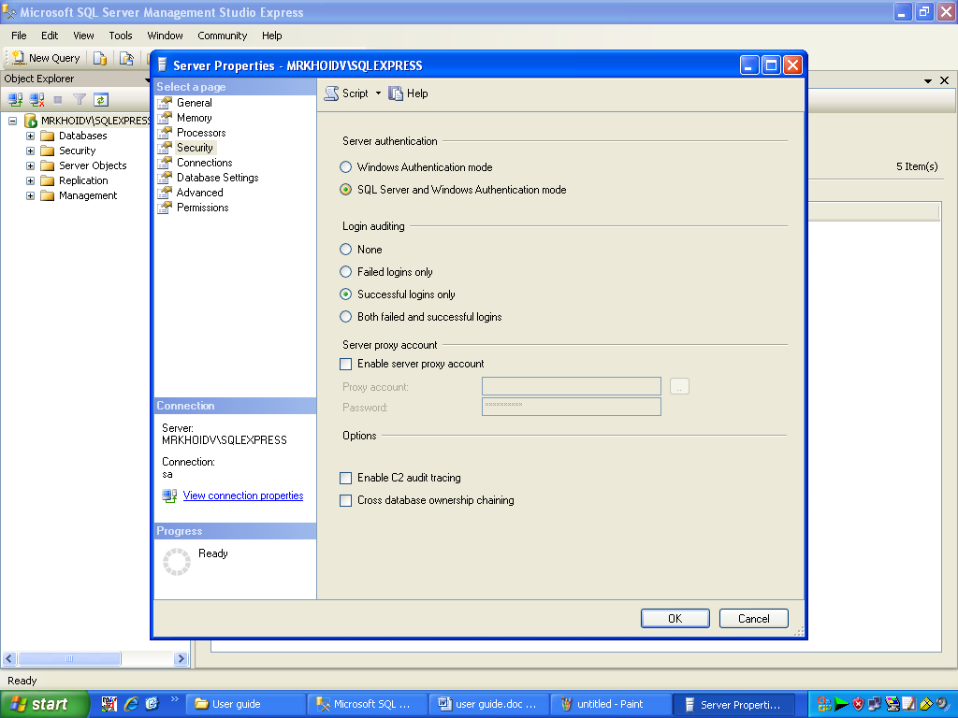

step 4 :

Set Login Properties - sa (defautl)

password : 123456
Confirm : 123456
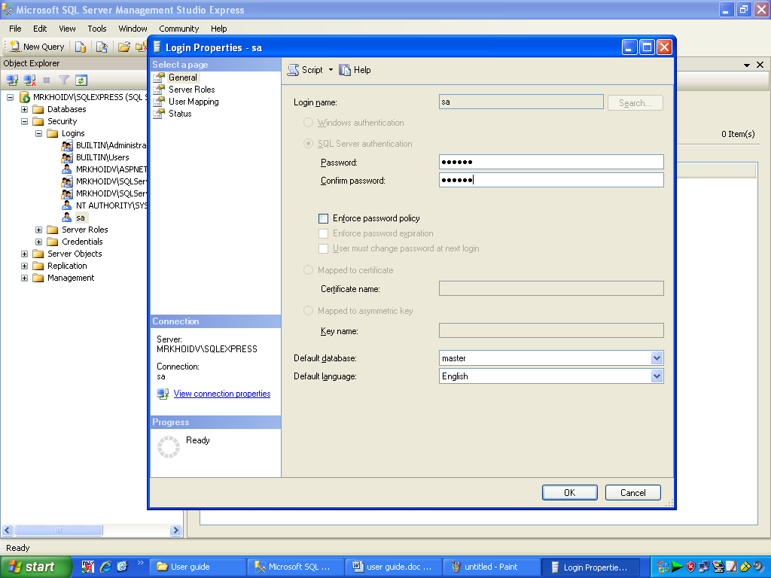

step 5 :
Connect to server

Login : sa
Passsword : 123456

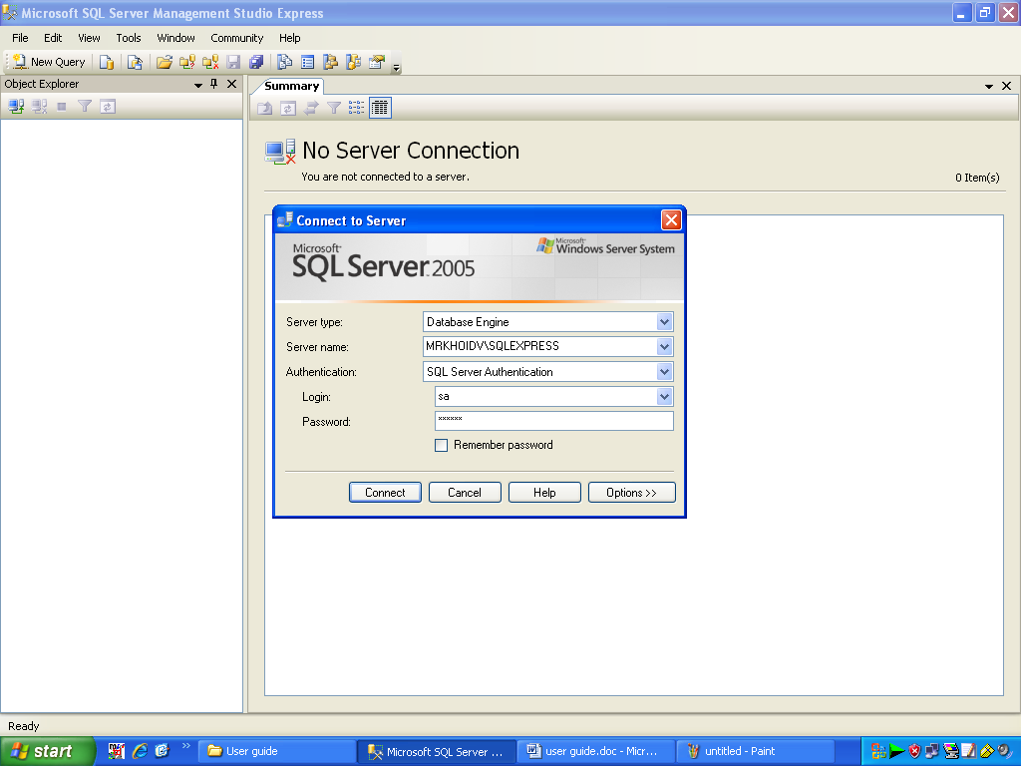

step 6 :

Select file MSBDB.sql
from eProject\eProject\database\ MSBDB.sql
Open with SQL server 2005 --> Execute

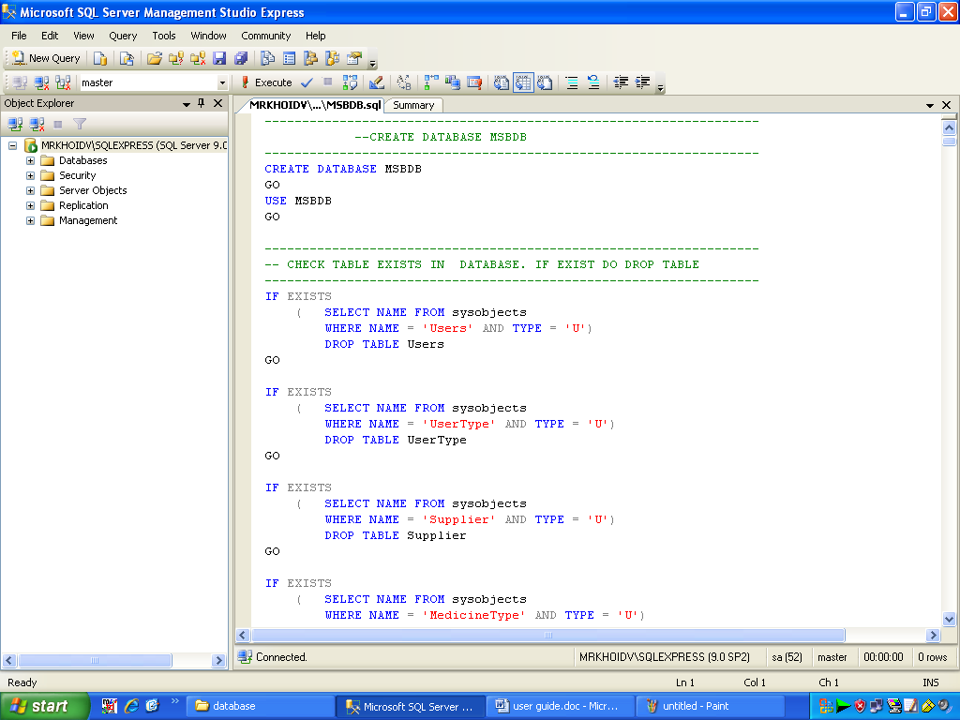

2. System mange guide

step 1:
Add JAR/Folder in to Library
from eProject\eProject\MedicalStoreBilling\library

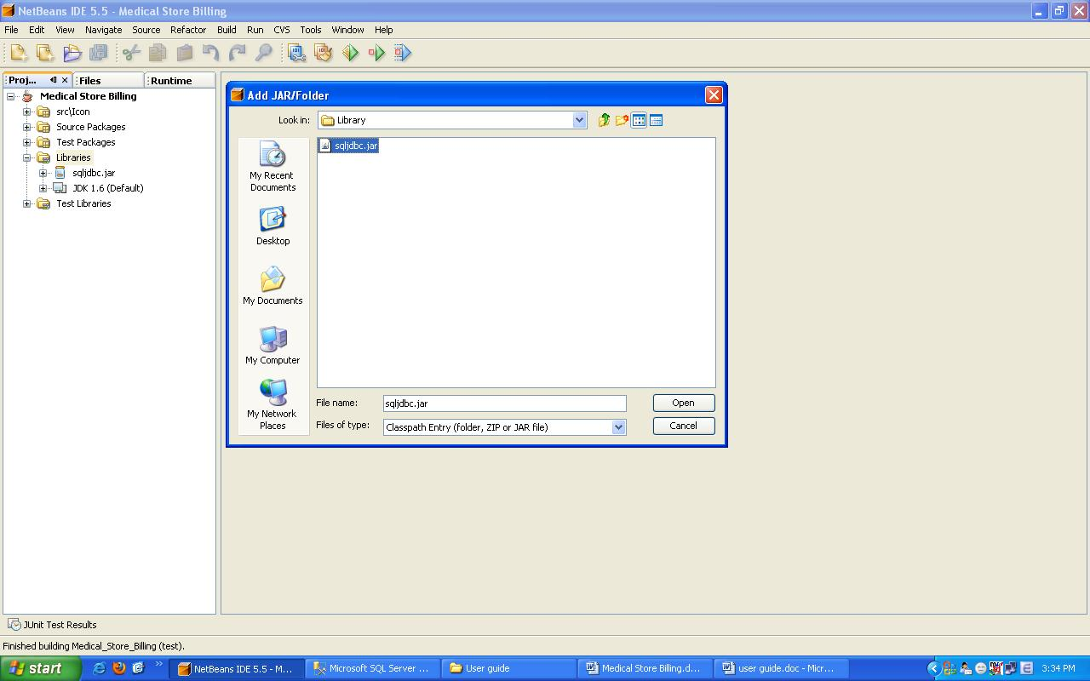

step 2 :
Run project MedicalStorBilling

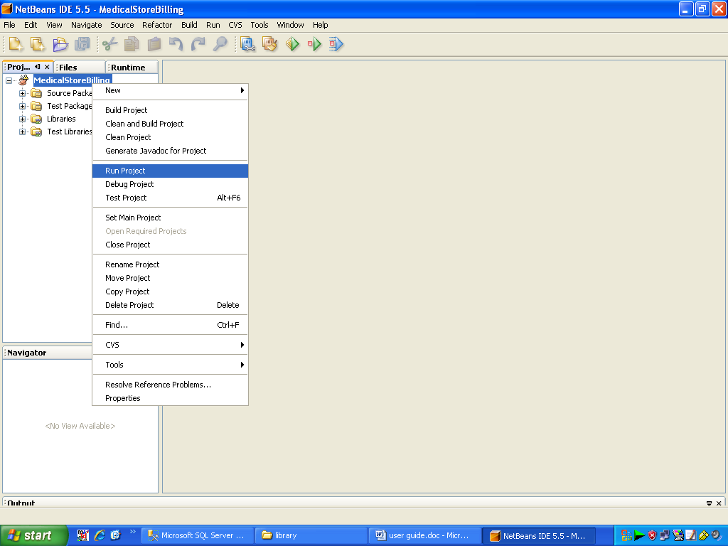

step3 :
Note: Software run well on resulation 1280x800
Login to MedicalStoreBilling

User Name : hientv
Password : hientv

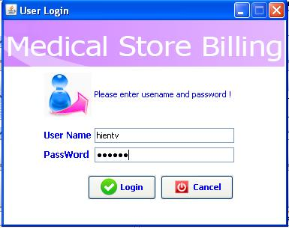

step 4 : System main

